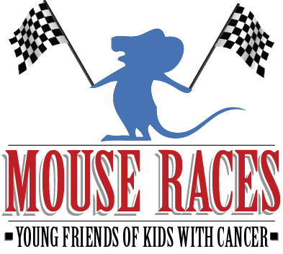
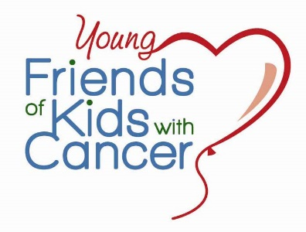
4th Annual Night at the Mouse Races
Saturday, September 19th at 7pm
Shrewsbury Community Center
5200 Shrewsbury Ave.
Shrewsbury, MO 63119

Your participation will be helping kids with cancer…be kids.

Sponsorship Form
Please check preferred sponsorship and enter payment information at bottom.
Title Sponsor - $1,000 (One space available)
- Presenting Sponsor rights
- Vinyl Banner displayed at event
- A Free table of 8 to the event
- Recognition on Young Friends of Kids website, event emails, invitation, event press releases, and throughout the event
- Full page ad in event program

Roulette Sponsor- $500 (One space available)
- Signage at roulette table
- Recognition during each round of roulette and on Young Friends of Kids with Cancer website
- Half page ad in event program

Race Sponsor - $250 (Seven spaces available)
- Logo displayed at betting table
- Recognition during race, on Young Friends of Kids with Cancer website, and in event program

In Kind Donation
Please consider making an in kind donation such as a raffle item, water or soda.

Contact Name: _______________________________________ Phone: _________________________
Address: ____________________________________________ City: ___________________________
State: ___________ Zip: _____________ Email: ___________________________________________
Amount $: _________________________ Visa MasterCard Discovery Check Enclosed CC #: __________________________________________________ Exp. Date: _____________________ Signature: ____________________________________________________________________________
For sponsorship information or to register online, visit: www.friendsofkids.com
Young Friends of Kids with Cancer, 530 Maryville Centre Dr., LL5, St. Louis, MO 63141. (314) 275-7440 Friends of Kids with Cancer is tax deductible organization according to the Internal Revenue Service Code 501 (c)3.

