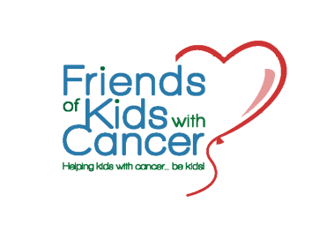
Young Survivors’ Scholarship Program
530 Maryville Centre Drive, Suite LL5
St. Louis, MO 63141
(314) 275-7440
2018 - 2019 Academic Year
Friends of Kids with Cancer, Inc. is pleased to offer a Young Survivors’ Scholarship Program. This scholarship is awarded ONE-TIME with the approximate amount of $2,000 and $3,500, depending on how many applicants meet the requirements. Therefore, it is very important that you fully complete your application with required attachments. Monies will be paid directly to the accredited institution, one-half each semester. Decisions as to which applicants receive the scholarship would be made by a majority of the members of the Service Review Committee. All decisions made by the Friends of Kids with Cancer Scholarship Review Committee shall be made in their sole discretion and all decisions of Friends of Kids with Cancer are final. To be eligible for a Friends of Kids with Cancer scholarship, one must:
- Have had a diagnosis of cancer or similar blood related disease before the age of 19 and/or treated for a pediatric form of cancer or similar blood related disease.
- Sought treatment for cancer or similar blood related disease in the St. Louis Metropolitan area.
- Received services from Friends of Kids with Cancer during treatment.
- Be a high school senior, or not out of high school more than 4 years, or if already in college, have a GPA of at least 2.0 (based on a 4.0 scale).
- Be accepted to an accredited university, graduate school, community college, vocational technical school, trade school, or other accredited facility.
- Be sure to include all documents listed below; together in one envelope (please write your name on each document you submit). Faxes not accepted for any part of this application:
  - Completed application form.
  - Two recommendations; one from a physician (on his/her letterhead) verifying diagnosis and one from an adult age 21 or older who is not a relative.
  - An acceptance letter from a scholastic institution on letterhead.
  - An official transcript of academic records from high school or college, whichever is applicable. Some institutions require the transcript be mailed directly to our office; please indicate if that is applicable in your case.
  - A one page (no more) essay describing your life experiences, your future goals, and the reasons why you need and deserve this scholarship grant.
While our scholarship is not need-based, needs will be considered. The Service committee of Friends of Kids with Cancer will evaluate each new application based upon the essay/goal statement, academic achievement, and community service. This committee will convene in late June, 2018, to decide the new awardees for the
2018 - 2019 academic year.
The scholarship is intended to be offered on an annual basis and is non-renewable, but Friends of Kids with Cancer reserves the right at any time for any reason to refrain from offering the scholarship in a particular year. For the 2018-2019 academic year, applications will be accepted until June 13, 2018. Information regarding the scholarship will be placed on the Friends of Kids with Cancer website, www.friendsofkids.com. Questions regarding the scholarship can be directed to Brandy at (314) 275-7440;
brandy@friendsofkids.com.

Friends of Kids with Cancer is devoted to enriching the daily lives of children undergoing treatment for cancer and blood related diseases. Our Mission is to be an advocate for these special kids and provide them and their families with the recreational, educational, and emotional support needed throughout the long hours of chemotherapy, illness and isolation.

