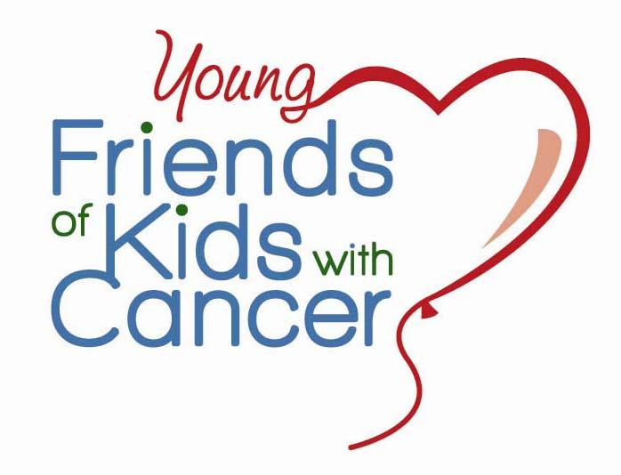
530 Maryville Centre Drive • Suite LL5 • St. Louis, MO 63141
(314) 275-7440 • Fax (314) 275-7446
www.friendsofkids.com/young-friends-of-kids.html

Dear Friend,

I would like to invite you to support our Mouse Derby: Run for the Roses! on May 12th at the Sunset Hills Community Center. All sponsorships and donations help kids with cancer being treated in the St. Louis area. The most important element in all of this is the cause. Here are some of the many ways Friends is able to help the children and their families through our Educational, Emotional, and Recreational programs thanks to your support of our Mouse Races;

*For a child suffering from cancer (along with their siblings and parents) your sponsorship will provide…

*Art Therapy so that the kids can openly express their feeling, confusion, and fear.
*Educational and Motivational Assistance (tutoring) developing self-esteem and more motivation while combating long term cognitive effects caused by severe cancer treatments.
*Play Therapy to allow kids with cancer to express their feelings about themselves and experiences using various play media.
*Treat a family to a special outing AWAY from his/her treatment center.
*Toys for the toy closet to help erase all the bad episodes of their painful treatment.
*Special Assistance/Relapse Gift to boost their morale and give hope, comfort, and energy

Can you imagine a better use of your sponsorship…plus, it’s tax-deductible!

Please see the attached information for sponsorship and participation information. We will be having a raffle as well so any items or certificates to fill the baskets with is greatly appreciated! I would be happy to meet with you to explain further the exciting new things we are doing to help kids with cancer…be kids. Thank you for your consideration.

Warmest regards,

Your Friends on the 2018 Mouse Race Committee

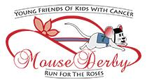
Mouse Derby
Run for the Roses!

Saturday, May 12th at 7pm
Sunset Hills Community Center
3915 S. Lindbergh Blvd
Sunset Hills, MO 63127

Sponsorship Form
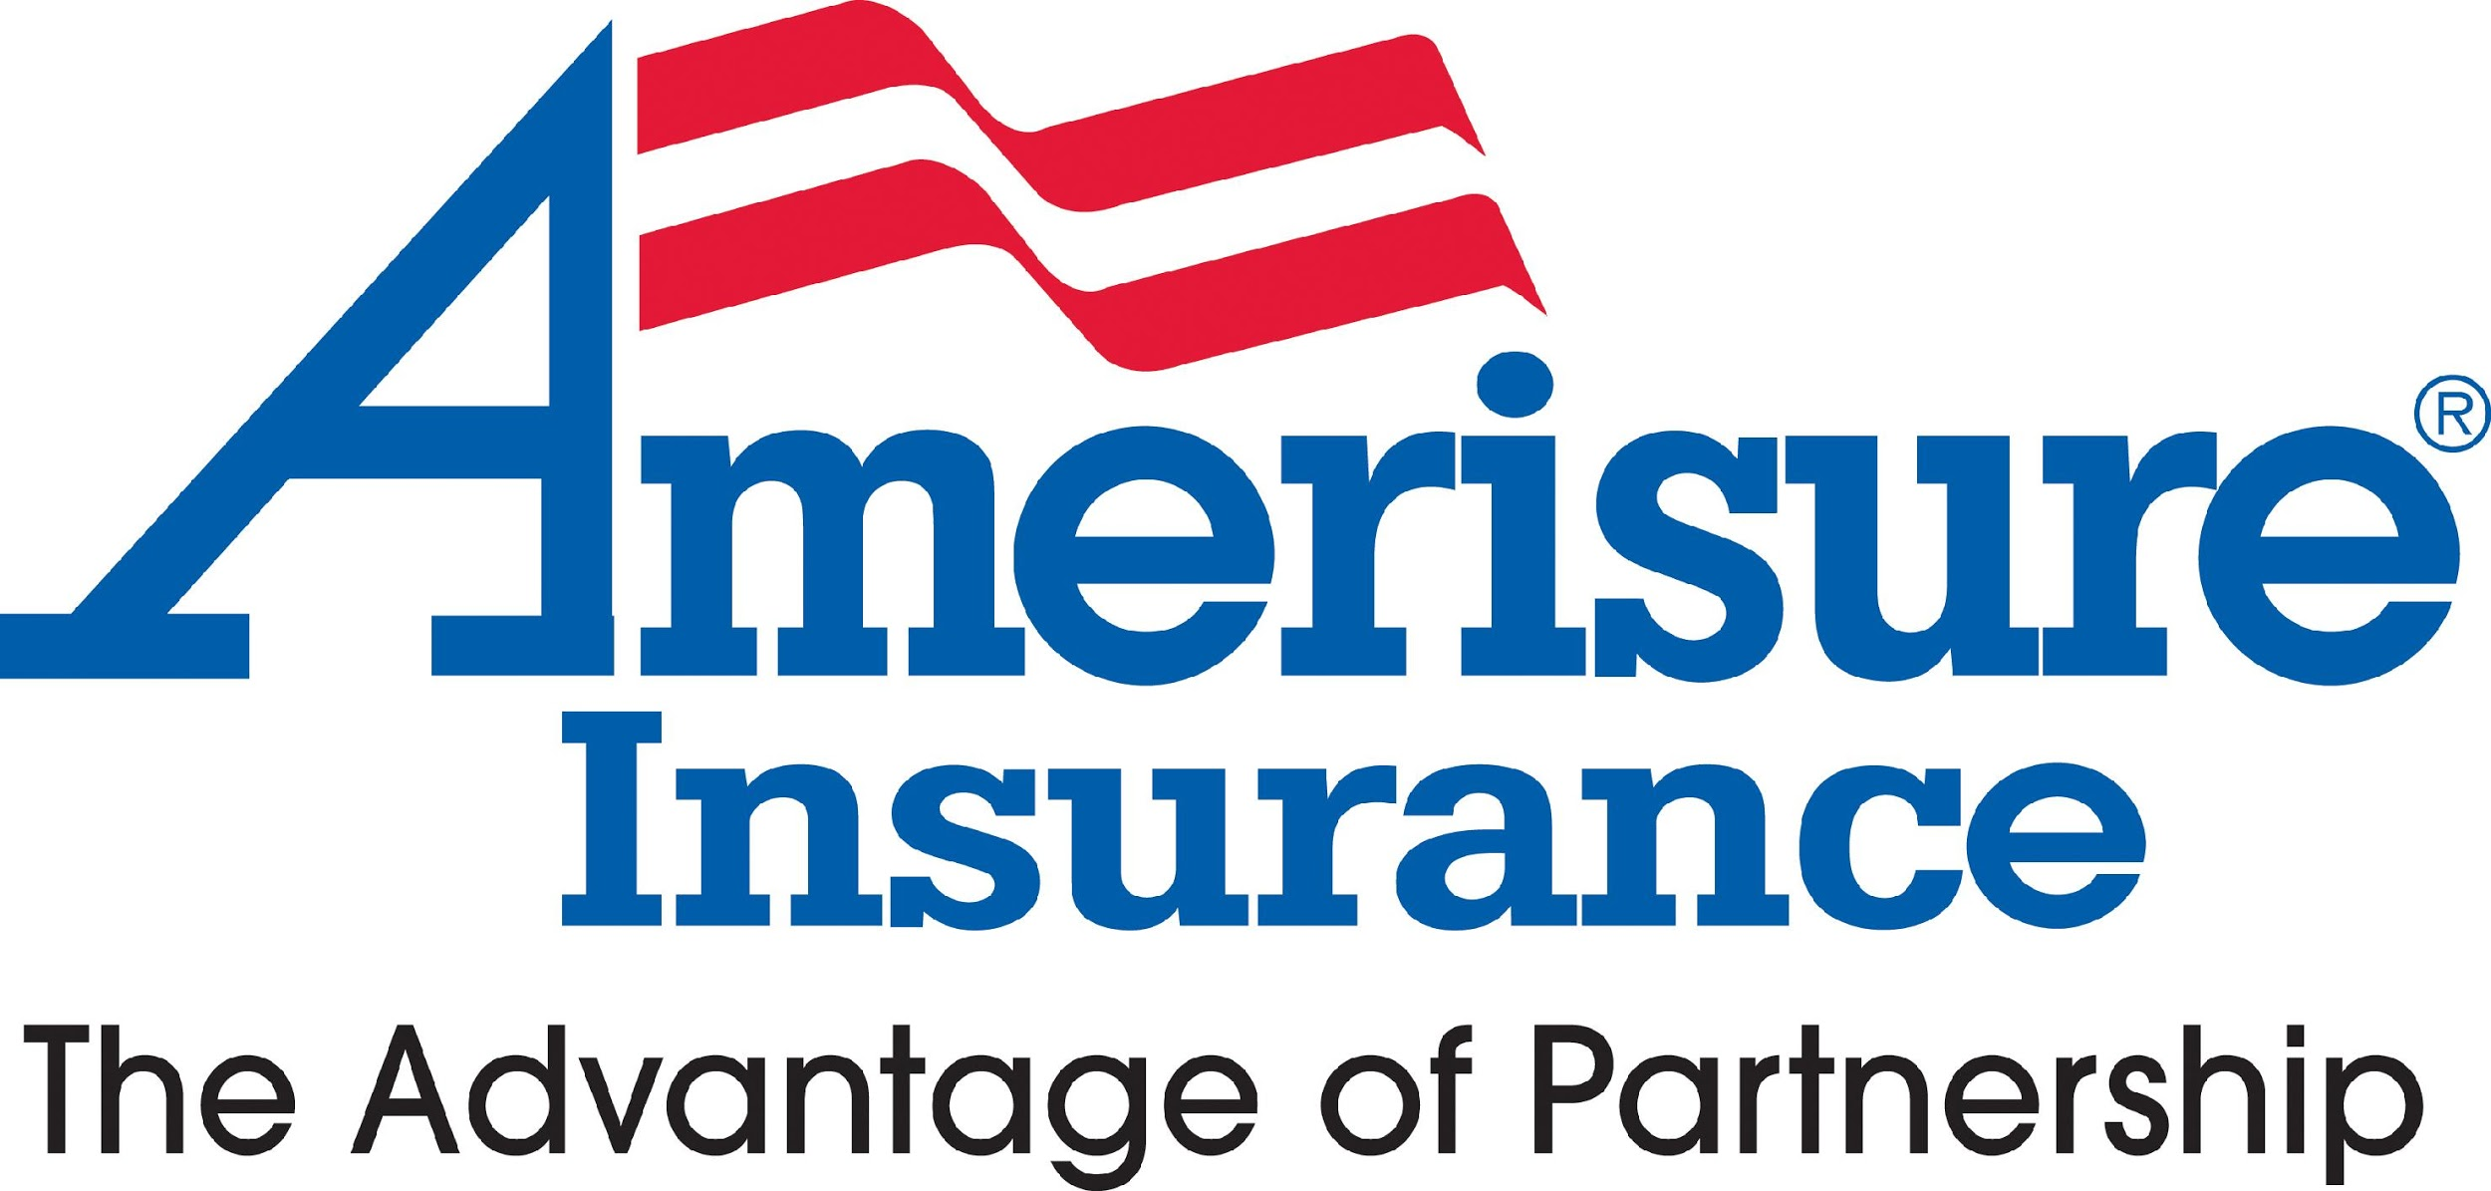
Fulfilled Title Sponsor
- Presenting Sponsor rights
- Vinyl banner displayed at event
- A free table to the event
- Recognition on Young Friends of Kids website, event emails, invitation, event press releases, and throughout the event
- Full page ad in event program

Roulette Sponsor- $500 (Two spaces available)
- Name or logo advertised during each round of roulette and on Young Friends of Kids with Cancer website
- Half page ad in event program

Race Sponsor - $250 (Seven spaces available)
- Name or logo displayed at betting table, recognition during race, on Young Friends of Kids with Cancer website, and in event program

In Kind Donation
Please consider making an in kind donation such as a raffle item, water or soda.

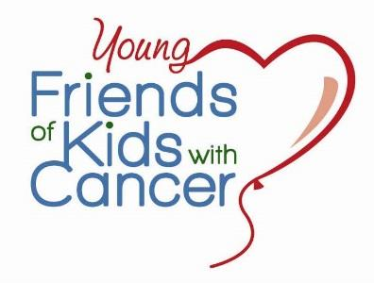
Sign up online at friendsofkids.com/mouse-races.html
Your participation will help kids with cancer…be kids!

For sponsorship information or to register online, visit: www.friendsofkids.com
Young Friends of Kids with Cancer, 530 Maryville Centre Dr., LL5, St. Louis, MO 63141. (314) 275-7440 Friends of Kids with Cancer is tax deductible organization according to the Internal Revenue Service Code 501 (c)3.

Mouse Derby
Run for the Roses!

Saturday, May 12th at 7pm
Sunset Hills Community Center
3915 S. Lindbergh Blvd - Sunset Hills, MO 63127

$25 per person / $200 per table
Tickets will be available at the door for $30
Includes Mint Juleps, Beer, Soda, and Water;
Attendees welcome to bring own food and liquor

Doors open at 6:30pm
Races begin at 7pm

Register online at friendsofkids.com/mouse-races.html
Your participation will help kids with cancer…be kids!

For sponsorship information or to register online, visit: www.friendsofkids.com
Young Friends of Kids with Cancer, 530 Maryville Centre Dr., LL5, St. Louis, MO 63141. (314) 275-7440
Friends of Kids with Cancer is tax deductible organization according to the Internal Revenue Service Code 501 (c)3.

